The GMS1 form – Guidance for GP Practices submitting EHIC and S1 Information

As part of the 2017/18 GMS contract agreement the Department of Health and Social Care, NHS England and the GPC agreed to include some supplementary questions in the GMS1 form.
The supplementary questions should be provided to all patients along with the registration form; however, patients are not required to complete the questions in order to register. Should a patient complete the questions then practices should follow the agreed process, described below.
The information will allow the NHS to identify EEA patients who have an entitlement to a non-UK EHIC, or S1 form (see page five for information on the S1). EEA patients who do not have their EHIC with them can ask their member state for a Provisional Replacement Certificate (PRC). These EEA patients can use their EHIC or PRC to access treatment in the NHS, with the UK then recovering the costs of any treatment from their respective member state.
There are also three tick boxes included in the supplementary questions:
a) I understand that I may need to pay for NHS treatment outside of the GP practice
b) I understand I have a valid exemption from paying for NHS treatment outside of the GP practice. This includes for example, an EHIC, or payment of the Immigration Health Charge (“the Surcharge”), when accompanied by a valid visa. I can provide documents to support this when requested
c) I do not know my chargeable status

The Process
If a patient does not complete any of the supplementary questions, then register the patient as per your standard process. There is no new action to take with no requirement to send the GMS1 or supplementary questions onwards.
If a patient completes the EHIC or PRC details, or the tick boxes, then GP practices should follow process A.
If a patient has an S1 form, then GP practices should follow process B.
Please note: GMS3 forms should not be sent to NHS Digital and GMS1 forms should not be used to capture EHIC/PRC details for temporary patients and then sent to NHS Digital.
Process A - Receiving and processing non-UK EHIC/PRC and/or tick boxes by GP practices
New patient completed registration form, signs patient declaration, and completes EHIC/PRC details and/or tick box details if appropriate
GP practice provides patient with registration form and supplementary questions
START.
New patient presents at GP practice

GP practice reviews form to ensure registration is completed
Patient hands completed form/s back to GP practice
Registration form signed by GP practice and patient declaration kept by GP practice. END

NO
GP practice takes a scan of registration form, including supplementary questions (patient declaration, tick boxes and/or non-UK EHIC/PRC details), and sends an email, as per ‘Process A – detailed notes’ (see page 3) to NHS Digital to process. Original versions of the registration form, including supplementary questions, retained by the GP practice

NHS Digital receive email from practice and process the information provided by the patient in the supplementary questions. END.
Has the patient completed EHIC/PRC details and/or tick boxes?

YES

Email Address: nhsdigital.costrecovery@nhs.net
Process A – detailed notes
To ensure that NHS Digital are able to process EHIC, PRC or tick boxes in a timely manner, GP practices are asked to:
- Capture the/a single patient’s name ONLY in the subject line of the email.
- The email must be sent from an NHS.net account and must include the practice details in the signature so the GP practice can be contacted in the event of any issues with the process/form.
- Each patient must have only one attachment i.e. both sides of the GMS1 form in one scan.
- Do not send the details of multiple patients in one attachment as these will not be processed.
- Not send other materials such as copies of passports, biometric residence permits, utility bills, practice questionnaires or clinical data to NHS Digital.
- Each attachment should be in one of the following formats: txt, msg, pdf, doc, docx, csv, xls, bmp, gif, jpg, rar, tif, tiff, jpeg, xps
- doc and docx files must be created using Office 365 and MS Office. Do not send doc and docx files created in open source equivalent of MS Word such as Libre Write as they are not supported by NHS Digital systems.
- Ensure each attachment does not exceed 5MB in size.
- Multiple attachments, each containing both sides of a GMS1 for only one patient, may be added to a single email.
- For batch returns, the total size of the attachments combined must not exceed 35MB.
No-one should be denied NHS primary medical care or refused registration at a GP practice because they do not complete the supplementary questions on the new GMS1 form.

Process B- Receiving and processing S1 information by GP practices

New patient completed registration form, signs patient declaration, and completes EHIC/PRC details and/or tick box details if appropriate
GP practice provides patient with registration form and supplementary questions
START.
New patient presents at GP practice

Has the patient indicated that they have an S1 form?
GP practice reviews form to ensure registration is completed
Patient hands completed form/s back to GP practice

Yes
NHS BSA receive email from practice and process the information provided by the patient in the supplementary questions. END.
GP practice takes the S1 form or a copy of the form from the patient and sends an email, as per ‘Process B – detailed notes’ (see page X) to NHS BSA.

No

Email Address: nhsbsa.faregistrationsohs@nhs.net
Registration form signed by GP practice and patient declaration kept by GP practice. END
Process B – detailed notes
S1 forms are issued to people who live in one EEA country, but have their healthcare costs covered by another EEA country. People entitled to apply for an S1 include state pensioners and those in receipt of certain benefits, for example survivors’ benefits and certain disability benefits. It also includes people who have been posted to work in another country (once they have lived there for two years) and frontier workers (people who commute across a country border to get to work). Family members are also covered by the S1 form.
S1 forms must be registered in order for the money to be recovered. If a patient has not already registered their S1 form with the Overseas Healthcare Team, the GP practice can offer to email/post it off for them.
You can register S1 forms by sending them to the Overseas Healthcare Team at the NHS Business Services Authority who will process the form. Registering an S1 form allows the UK to claim around £4,500 per person, per year, towards their healthcare costs, regardless of how much healthcare the person needs, from the appropriate country. There is no deadline for processing S1 forms.
By registering the form once it automatically means that £4,500 is recovered every year – it does not have to be re-registered each year. Any money claimed goes back into the NHS.
- NHS BSA DO NOT require the GMS1 form to be sent to them in order to process the S1.
- GP practices can batch up any S1 forms they receive and send scanned copies to BSA on a monthly basis.
If the patient does not have their S1 form to hand at the time of registration, there is no requirement for the practice to chase it up in order for the patient to be registered.
No-one should be denied NHS primary medical care or refused registration at a GP practice because they do not complete the supplementary questions on the new GMS1 form.

Frequently Asked Questions
- Many practices use a bespoke patient registration form. However guidance states that practices are required to provide all new patients with the revised GMS1 form, which includes supplementary questions to help determine a patient’s eligibility to healthcare. Can practices continue to use their bespoke forms but also provide the supplementary questions so that they can continue to process their forms as they have done so previously and then send the new section to NHS Digital?
Answer:
If practices wish to update their bespoke forms with the supplementary questions embedded, then this would be acceptable practice.
- Practices would need to use the provided GMS1 form or embed the supplementary questions in their bespoke form so it is not possible to separate the two sets of information.
- In order for NHS Digital to correctly match the patient’s record to add their EHIC details to, the patient details from the registration form (Surname, first name, address, DOB, NHS number (where known) etc)and the supplementary questions need to be emailed as a single black and white attachment per patient, not exceeding 5mb in size – please see process A for more details.
- Where a practice has introduced their own questions into the registration process, , do NOT scan and email these to NHS Digital unless they relate to the EHIC or S1.

- Can GP practices that receive very high volumes of registrations, for example, a university GP practice, return the forms in batches?

Answer:
GP practices may submit in batch as per the ‘Process A – detailed notes’ section of this guidance document.

- Do overseas patients registering as temporary patients (using GMS3) also need to complete the GMS1 supplementary questions?

Answer:
No, the GMS1 form should only be used to register permanent patients. GP practices should continue to use the GMS3 form for temporary patients. If they have a non-UK EHIC and need to seek secondary care, they should present their EHIC at that point in time. Without an NHS record, there is nowhere to store EHIC information for the patient. GMS3 forms should not be sent to NHS Digital and GMS1 forms should not be used to capture EHIC/PRC details for temporary patients and then sent to NHS Digital.

- We have been given the GMS1 forms and are unclear about what we need to do.

Answer:
- Use the new GMS1 form for all permanently registering patients.
- If a patient has completed the non-UK EHIC or PRC fields or tick boxes on the new GMS1 form, please send this to NHS Digital – see Process A above.
- If the patient has indicated they have an S1, please send just the S1 form to the Overseas Healthcare Team – see Process B above.
- If the patient does not complete any of the supplementary questions, you do not need to send the GMS1 or the supplementary questions form to NHS Digital. You should continue to register the patient following your standard permanent patient registration process.

- What should we do if the patient doesn’t have their S1 form with them when they register?
Answer:
- Register the patient in the normal way. The patient can post or email their S1 form directly to NHS BSA.

- The patient has completed the EHIC fields, but country code says UK. What should we do with the form?
Answer:
- If a patient has added their UK EHIC details to the form, the practice should register the patient in the normal way but does not need to scan and email the form to NHS Digital.

- Our practice does not have a sufficient number of forms to meet patient demand, what should we do?
Answer:
- An initial distribution of 750,000 new GMS1 forms was made to GP practices ahead of the 2 October transition date. A further 1,425,000 forms (ordered in blocks of 50 forms) were made available for ordering through the PCSE portal .

- In order to manage short-term demand, practices may have had their order size reduced to 20 blocks/1000 forms at a time. As long as practices place orders based on anticipated registration volumes, rather than try to stock up for the year, there should be sufficient stock for all practices to be able to register all their patients.

- Further stock will be available for ordering via the PCSE portal, but we anticipate that PCSE should be able to respond to local demand as and when it arises. In the event that practices do run out of stock, the new GMS1 form is available for download, enabling practices to print the form directly.
If practices have copies of the old GMS1 form, they can also use these alongside the supplementary questions, but practices need to ensure that all patients are provided with both the old GMS1 and the supplementary questions, and that where a patient completes the supplementary questions; both forms are emailed to NHS Digital as a single attachment.
The patient leaflet can also be ordered or downloaded through the PCSE portal.

- Is the GMS1 form available in large format?

Answer:
The GMS1 form is available to GP practices in large format. This will be made available for download on the PCSE portal.

- Is the GMS1 form available in different languages?

Answer:
As with the previous version of the GMS1 form, the revised form is currently only produced in English. We will review this decision if feedback from practices indicates there is demand for the form to be produced in different languages.

- What is meant by being ‘ordinarily resident’ in the UK?

Answer:
Entitlement to free NHS services outside of primary medical care is principally based on Ordinary Residence in the UK. An overseas visitor is any person who is not “ordinarily resident” in the UK. A person will be “ordinarily resident” in the UK when that residence is lawful, adopted voluntarily, and for settled purposes as part of the regular order of their life for the time being, whether of short or long duration. Nationals of countries outside the European Economic Area (EEA) must also have ‘indefinite leave to remain’ in the UK in order to be ordinarily resident here. A person who is ordinarily resident in the UK must not be charged for NHS services, except where statutory charges apply, e.g. prescription charges.

There is no requirement to be ordinarily resident in the UK to register with a GP practice as an NHS patient.

There is no requirement for an EEA national to have a ‘right to reside’ under the terms of the European Free Movement Directive, to meet the ordinarily resident test.

GP practices are not required to assess if charges apply to overseas visitors.

More information on ordinary residence can be found in Guidance documents at https://www.gov.uk/government/publications/guidance-on-overseas-visitors-hospital-charging-regulations

- What does an EHIC, PRC or S1 look like?

Answer:
Sample European Health Insurance Card:

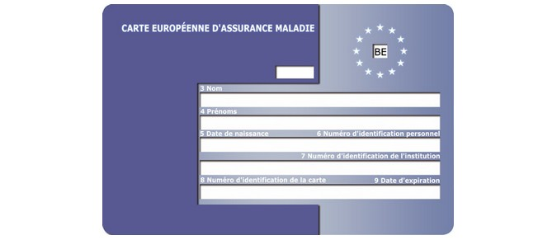

The cards can be easily recognised. The front of the card looks the same across all member states, and carries the same information for each country, although in different languages. The back of the card can vary from country to country.

Sample Provisional Replacement Certificate:
Sample S1 form - front:
S1 form – back:
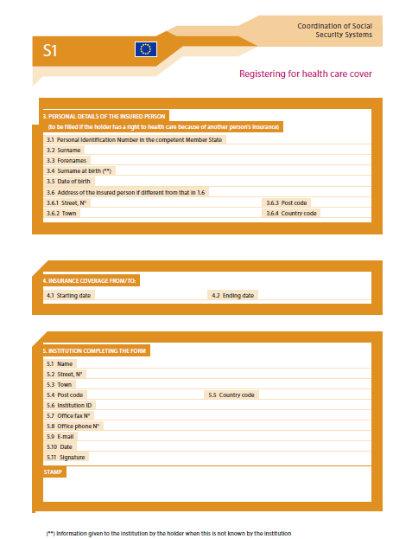
Practices with any further queries with regards to the form, should direct these to the BMA info.gpc@bma.org.uk

